**HTML HEADINGS**

* HTML headings are titles or subtitles that you want to display on a web page.
* They are represented as <h1>… </h1>.
* The headings range from h1 to h6 , h1 being the largest and h6 being the smallest.
* Example :

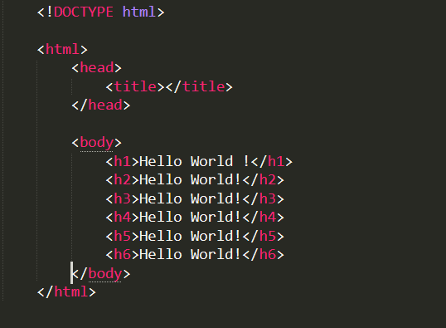

* OUTPUT :

